Budget Presentation

Fiscal Year 2021/2022

*“Servicing the community of Crooked River Ranch by providing superior service through prevention, education, emergency response and community involvement.”*

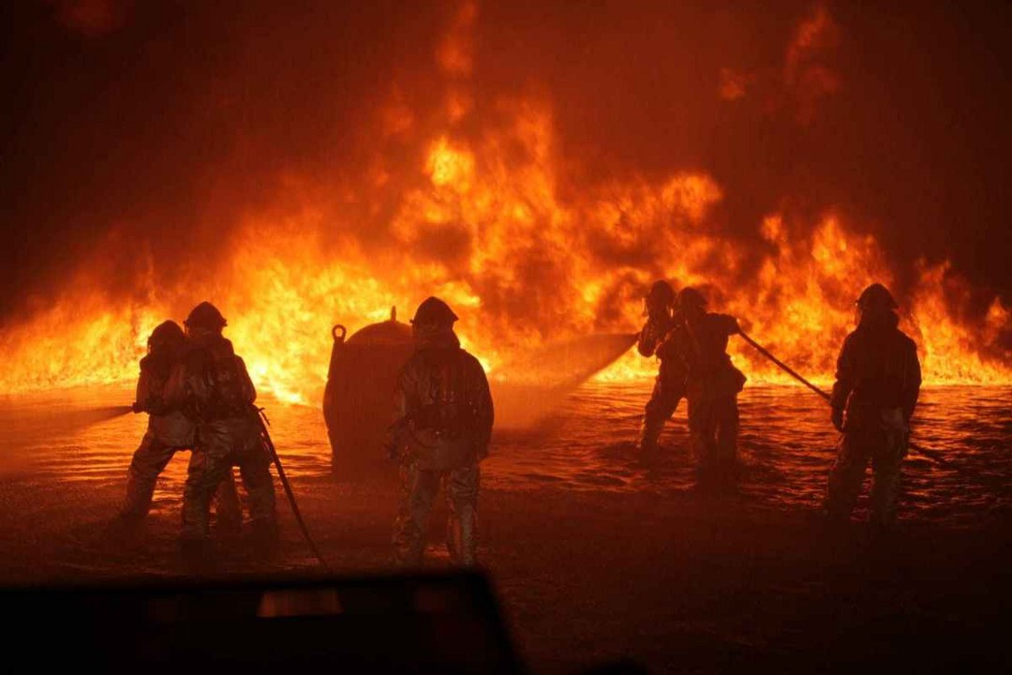

**Table of Contents:**

Message from your Fire Chief…………………………………………………...Page 3

Introduction of Budget Committee Members…………………………...Page 4

About our District……………………………………………………………………...Page 5

Organizational Chart………………………………………………………………… Page 6

Economic Factors/Assumptions………………………………………………...Page 7

Significant Budget Needs/Challenges………………………………………...Page 8

Top 10 Taxpayers for Deschutes/Jefferson County…………………….Page 9

Accomplishments/Opportunities in 2020/2021………………………….Page 10

Developing Goals/Objectives for 2021/2022……………………………...Page 11

Basis of Accounting/Budget Process……………………………………………Page 12

Budget Calendar………………………………………………………………………...Page 13

Grant and Opportunities…………………………………………………………….Page 14

Income Resources for the General Fund…………………………………….Page 15/16

Expenditures: Personnel Services……………….……………………………...Page 17/18

General Fund/ Expenses: Materials & Services…………………………...Page 19

General Fund/ Expenses: Capital Outlay/Grant Awards……………...Page 20

General Fund/ Expenses: Debt Services……………………………………...Page 21

Capital Reserve Fund…………………………………………………………………. Page 22/23

Bond Fund…………………………………………………………………………………. Page 24

Budget Variance/General Fund (March 2021)……………………………. Page 25/26

Core Values………………………………………………………………………………...Page 27

 ***A Message from your Fire Chief***

Dear Residents, Budget Committee members, Board of Directors, and members of Crooked River Ranch Fire & Rescue,

First, I would like to thank you for your support and dedication to our Fire District. I am honored to present the budget for the 2021/2022 fiscal year for your consideration. Our District’s on-going efforts are focused on balancing the level of service Crooked River Ranch Fire & Rescue provides with the resources that are available. The budget is intended to serve as a financial plan for the next fiscal year, outlining forecasted resource and expenditure requirements, with the result being a balanced budget. The 2021/2022 fiscal year budget has been prepared using conservative revenue/resource projections and realistic, yet anticipated expenditure requirements.

The District is continuing the process of developing and refining both the long-term financial projection along with the adopted Strategic Plan. These plans will be used to assess and project for future needs, budgets, directions, and reserves to meet the future needs of the District and guide us in service delivery. The District continues to explore alternative funding options as well as efficiencies as they present themselves.

Each year, the goal of the budget presentation is to give you valuable, transparent, and necessary information regarding the budgetary requirements of the District. This budget reflects participation from our Administrative staff, as well as our Captains. This is a product of many individuals’ time and effort and I believe it is a balanced, conservative, and is a workable budget for the 2021/2022. It continues to provide a foundation for the District to forecast future years and adjust as needed. This year we revised our presentation by giving you one document, instead of two, which will streamline the process and give the Budget Committee and Board room to make adjustments in the budget line items during the presentation.

I would like to thank the residents of Crooked River Ranch, the Budget Committee, Board of Directors and staff for their valuable input and suggestions during this budget season. Their efforts make the budget a document that can truly be used to manage the District in the coming fiscal year.

Respectively,

Harry Ward, Fire Chief & Budget Officer

***Vision Statement – “Provide the Best Service and Protection for our Community, in a Cost-Effective Manner.”***

 **Budget Committee Members** 

**Board of Directors** **Term Expires**

Jeff Green June 30, 2023

John Meredith June 30, 2021

Barbara Oakley June 30, 2023

Brad Pahl June 30, 2021

Mark W. Wilson June 30, 2023

**Budget Committee** **Term Expires**

Robert Bengtson 2020-2022

William Burt 2020-2022

Joseph Costigan 2021-2023

Kay Norberg 2021-2023

Debbie Sappenfield 2021-2023

**District Administration**

Harry Ward, Fire Chief

Sean Hartley, Assistant Fire Chief/Paramedic

Dana Schulke, Administrative Assistant

**About our District**

Crooked River Ranch Rural Fire Protection District operates out of one fire station, located on one of the main roads in Crooked River Ranch. Crooked River Ranch Rural Fire Protection District (the District) operates under Oregon Revised Statutes Chapter 478 as a separate municipal corporation and is managed by a 5-person Board of Directors. The District covers 16.4 square miles of rural residential, recreational, and commercial property. Crooked River Ranch is governed by mostly Jefferson County; however, a small portion of our District is governed by Deschutes County. According to the records from the Crooked River Ranch Homeowners Association, there has been an onset of families moving to Crooked River Ranch with an approximation of growth from 5,000 residents full time to 5,500- 6,000 residents.

The District currently maintains a fleet of apparatus consisting of (2) Advanced Life Support Ambulances, (2) Command Vehicles, (2) 5-ton Heavy brush trucks, (2) Water Tender’s, (1) Type 6 Wildland Fire truck, (1) Structure fire engine, (1) Interface fire engine, along with a trailer for our Rope Rescue operations.

Our staff consists of 6 full-time employees (Fire Chief, Assistant Fire Chief, Administrative Assistant and Three Captains which oversee our A, B & C Shifts). We currently have 17 Volunteers, as well as 6 student Volunteers from Central Oregon Community College.

The services we provide are augmented by the Central Oregon Mutual Aid Agreement that established a mechanism to received emergency response from regional fire agencies. Under this same agreement the District also provides services in the areas surrounding the District, as requested. These partners include the following: Redmond Fire & Rescue, Bend Fire & Rescue, Jefferson County RFPD #1, Cloverdale RFPD, Sisters-Camp Sherman Fire & Rescue, LaPine Fire & Rescue, Sunriver Fire & Rescue, Black Butte Ranch Fire District, Alfalfa Fire District, Warm Springs Fire & Safety, Jefferson County EMS, Oregon Department of Forestry, Bureau of Land Management and US Forest Service.

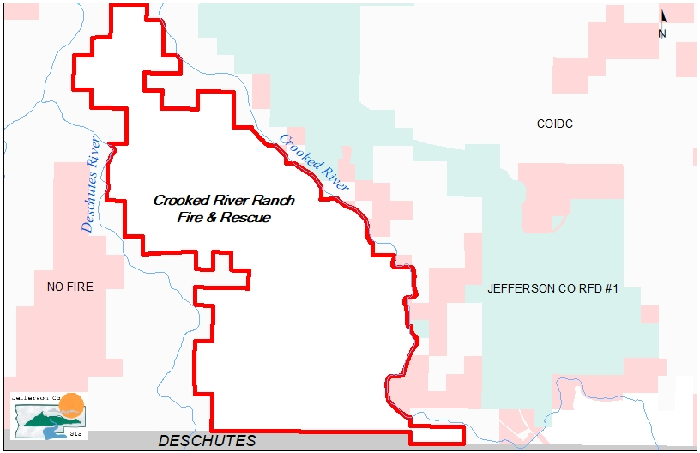

**Organizational Chart**

**Economic Factors / Assumptions**

**Debt**

Currently, the new only debt the District has incurred is the financing of the new ambulance, which we took possession of last year. Our goal is to have it paid off in the next four years by utilizing funds from our Capital Reserve fund.

**Financial Concerns/Factors**

As we approach the 2021/22 FY and a new President, the House of Representatives and the Senate have passed the Consolidated Appropriations Act (H.R. 133) in December of 2020, which will include the following:

* An increase that will fund the Assistance to Firefighters Grant (AFG) program at $360 million.
* An increase that will fund the Staffing for Adequate Fire and Emergency Response (SAFER)program at $360 million.
* An increase of the U.S. Fire Administration to $49.27 million.
* An increase to the Volunteer Fire Assistance program to $19 million to fight.

wildland fires.

* Authorization for the FEMA administrator to waive the following requirements to the FY 2021 SAFER grants;
* The three-year performance period.
* The local cost-share. The requirement that SAFER funds not supplant local funds.
* The requirement that the recipient fire department maintain its budget at 80% of the average funding over the past three years.
* The ability for fire departments to retain and re-hire firefighters.
* Authorization for the FEMA Administrator to waive the local match requirement for the AFG grants and the maintenance of expenditures requirements.

We are hopeful by seeing these changes we will be able to continue to apply for these programs and utilize these funds for the needs of the District.

**Significant Budget Needs**

The Budget Committee should note the following assumptions used in the upcoming budget preparation that may be significant in its overall impact on the District.

* Complete the fencing around our training grounds/property.
* Replace the current flooring/carpet in the building with better sustainable

products that will be easier to clean.

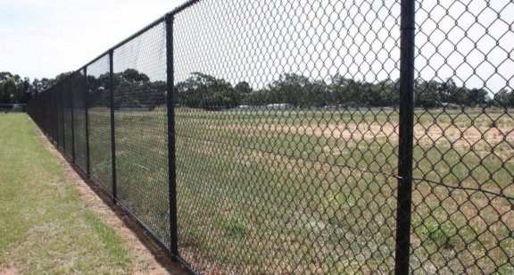

**Challenges We Face**

* Securing outside funding for retention of volunteers.
* Navigating new Federal/State regulations during COVID-19 pandemic.
* Understanding new State mandated responsibilities.
* Keeping our personnel safe during a pandemic and while fighting fires.
* Communicating to residents how important it is to maintain their properties.
* Not enough dormitory space for volunteers that pull 24-hour shifts.
* Maintaining current service levels with limited personnel on 2nd out calls.
* Rising increase in PERS contributions.

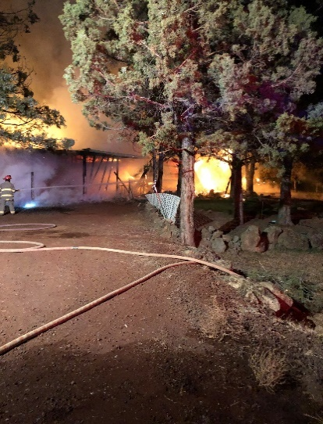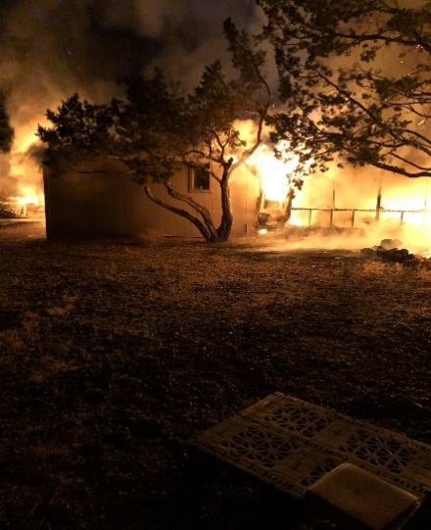

**Top 10 Taxpayers for Deschutes & Jefferson Counties**

**in 2020/2021**

**Deschutes County**

Company Taxes

1. PacifiCorp (PP&L) $1,922,717.16
2. TDS Baja Broadband LLC $1,797,663.78
3. Cascade Natural Gas $1,327,408.16
4. Gas Transmission NW Corp $1,100,474.89
5. CenturyLink Property Tax $ 979,223.37
6. Touchmark at Mt. Bachelor Village $ 798,249.07
7. Suterra LLC $ 743,180.95
8. CVSC LLC $ 708,497.14
9. Deschutes Brewery Inc $ 703,858.02

10)Bend Research Inc. $ 646,604,06

**Jefferson County**

1. Portland General Electric Co. $4,049,593.58
2. Gas Transmission Northwest Corp. $ 741,902.07
3. PacifiCorp $ 713,658.86
4. Bright Wood Corporation $ 534,437.47
5. Warm Springs Power Enterprises $ 252,003.24
6. Keith Manufacturing Co/Keith Investments $ 262,942.96
7. Apple, Inc. $ 167,093.25
8. BNSF Railway Company $ 164,370.99
9. ACI Real Estate dba Albertsons Co. $ 150,905.85

10) CenturyLink $ 148,358.20

 **Accomplishments/Opportunities in 2020/2021**

1) Construction our own training grounds behind the Station, which is nearly completed. The completion of this structure would have never happened without the donations of many building contractors, Les Schwab and 2 grants awarded by Department of Public Safety Standards and Training with the State of Oregon. One for $40,000 and the other for $35,000.

2) Acquired a new ambulance to replace an older one.

3) Developed a Community Risk Reduction plan for Crooked River Ranch.

4) Due to the COVID-19 pandemic we redesigned our own Student Academy with all students graduating.

5) Acquired a new SCBA compressor for the station, as well as new heart monitors for each of the ambulances through an AFG grant. We were also able to obtain a LUCAS CPR auto compression device through the AFG grant with leftover funds.

6) Collaborated with the Bureau of Land Management on clearing specific areas for fire defensible space near the Wilderness Study Area, as well as the alternative exit.

7) Some of our student volunteers were fortunate to go on a few state conflagrations to have firsthand experience with wildland fires this past September.

8) Deschutes County 911 assisted us with the purchase and installation of new network hardware. This included a new firewall/router, network switch, and VPN.

9) Acquired a maintenance application that is tied to our training software (Target Solutions). This electronically maintains all the apparatus maintenance records for the District. By purchasing this software application, we are now able to get daily alerts of when maintenance is due on every vehicle.

10) Reconstructed the Reader Board in front of the fire station.

**Developing Goals and Objections for 2021/2022**

* Continue to focus on firefighter Health and Safety with Cancer awareness

by working on better techniques for cleaning our equipment after fires.

* Focus on short safety messages before each training session.
* Develop and implement a promotional process that includes elements of written and practical exams.
* Develop a succession plan for each administrative position.
* Continue to hold quarterly officer meetings for professional development, as well as all officers to be trained to deliver the Attributes of Leadership course.
* Develop initiatives for improving Standards of Cover for emergency response using our Community Risk Reduction plan.
* Continue with Community Outreach programs, such as hands only CPR classes and our annual Emergency Preparedness Open House/Workshops.
* Share more fire prevention messages on our social media platforms.

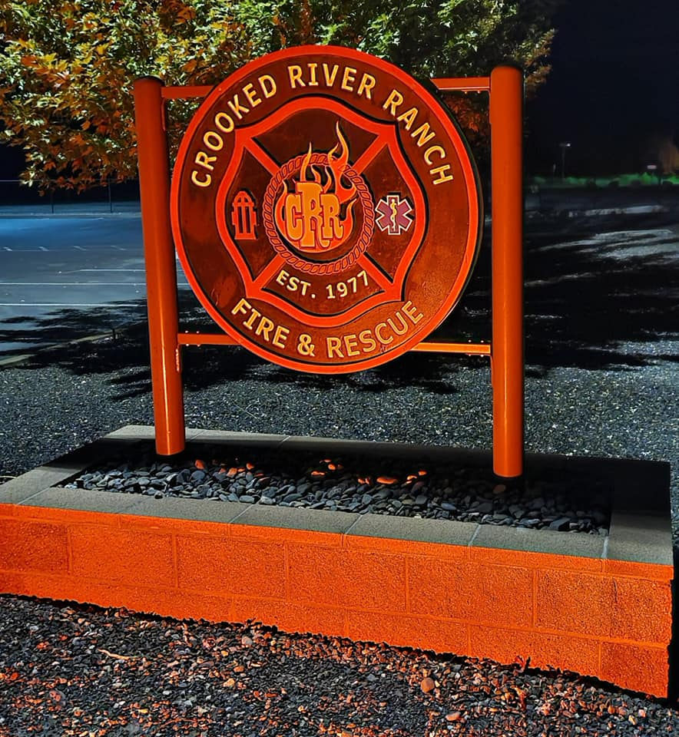

**Basis of Accounting / Budget Process**

The District’s budget operates on a modified cash basis of accounting. The District budgets all funds in accordance with the requirements of state law. Annual appropriated budgets are adopted for the general, debt service, and capital reserve funds. The budget document was developed to serve as the financial plan required to carry out the goals and objective for the ensuing fiscal year. It is intended to provide financial guidelines for programs and functions within the fire district. Separate summary pages are presented for the following categories: Personnel Services, Materials and Services, Capital Outlay, and other Expenditures to include special appropriations that are not included in the prior categories.

The budget process for the District begins with the appointment of the budget officer, which for the fiscal year of 2021/2022 is the Fire Chief. The proposed budget is created and includes historical and empirical data from previous budgets, external economic indicators and conditions and other factors that could impact the District’s fiscal environment. The staff works together in a collaborative effort to submit their individual budgets to the District administrative staff. The objective is to work together and come up with a budget that is fiscally sound. Once the proposed budget has been reviewed and balanced by the District Administrative staff, it then goes before the budget committee. This committee is made up of the five District Board members and five appointed community budget committee members. The Budget committee reviews the document, makes any necessary changes, and then approves the budget to go before the Board at the budget hearing. After adoption, the budget document is then submitted to Deschutes and Jefferson Counties.

Oregon law allows for the District to make changes to the adopted budget through two options depending on the amount to be appropriated. If the change is 10% or less than the annual budget, the supplemental budget may be adopted at a regular meeting and is adopted by a resolution. If the change is more than 10%, a public hearing is required, and the appropriation is adopted by a resolution.

**Budget Calendar**  

|  |  |
| --- | --- |
| DATE | ACTION |
| January 21, 2021 | **Appoint Budget Officer at Board Meeting** |
| February 18, 2021 | **Appoint Budget Committee Members by this date** |
| Friday, April 30, 2021 | **Budget is due for publication to Board/Committee members** |
| Wednesday, May 5, 2021 | **Publish 1st Notice of Budget Committee Meeting** |
| Thursday, May 13, 2021 | **Budget Committee Meeting** |
| Wednesday, May 19, 2021 | **Publish 2nd Notice of Budget Committee Meeting (if necessary)** |
| Thursday, May 27, 2021 | **Continuation of Budget Committee Meeting (if necessary)** |
| Wednesday, June 9, 2021 | **Publish Notice of Public Budget Hearing (LB50) in newspaper** |
| Thursday, June 17, 2021 | **Hold Public Budget Hearing prior to Board Meeting** |
| Thursday, June 17, 2021 | **Enact Resolution to Adopt Budget at Board Meeting** |
| Wednesday, June 30, 2021 | **File Form LB-50 & Submit Tax Certification to Deschutes/Jefferson Co.** |



Every year the District has opportunities to apply for several grants that assist the us in the needs of equipment, volunteer staffing and vehicle needs. In the last few years, we have been successful in receiving awarded funds for our District. Below you will find a list of resources that we applied for this past year to operate this District:

* State of Oregon Department of Public Safety Standards and Training
* Special Districts Association of Oregon for Safety & Security
* Oregon Department of Forestry Volunteer Fire Assistance
* FEMA Assistance to Firefighters
* FEMA Staffing for Adequate Fire, Emergency Response (SAFER)
* Coronavirus Relief Funds

We are looking into other opportunities of funding with the following organizations and foundations:

* The Gary Sinise Foundation
* Firehouse Subs Public Safety Foundation
* State Farm Companies Foundation Safety Grant for Disaster Preparedness and Disaster Recovery
* Firefighters Charitable Foundation
* Joey D Foundation

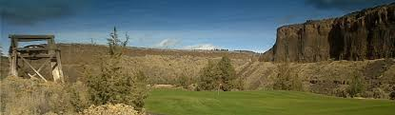

**INCOME RESOURCES:**

**Available Cash on hand** is estimates based on current spending forecasts for the remainder of fiscal year 2020/21. This line includes money from the base rate tax and local option levy tax.

**Previously levied taxes estimated to be received** are the total taxes owed for Jefferson and Deschutes Counties which are taken from the June 30, 2020 audit of Fire District funds. Historically we receive approximately one third of these owed taxes each year. The amount listed represents approximately 30% of the total owed taxes for both counties combined.

The **Interest** we are using is the prior year’s actual amount. This amount is estimated each year.

We are not anticipating any **Transferred IN, from other funds** into the general fund for this budget.

**Ambulance Billing** is based on an average from the revenue received from ambulance transports. This is compared to the number of ambulance transports, their billed amounts, and collections rates. The District is currently averaging 265 transports per year.

**Contractual Income** is contractual money received from outside agencies for contracted services, as well as money received for hosting Paramedic Internships through Central Oregon Community College.

**Emergency Address Sign** revenue for new and replacement signage is an estimated from prior year actuals. Currently, the requests for the signs have been steady which is a good indicator that we are seeing growth in our District.

**Fire Med** revenue is based on 281 active member accounts at $45 per membership. The memberships have decreased from the prior fiscal year. The current pandemic has caused hardships for some of our residents; however, we are hopeful the membership numbers will increase in the next budget year.

**Grant Funds** include funds received from the SAFER grant that we were awarded back in the 2017/2018 fiscal year. These funds are due to expire in December 2021.

**Miscellaneous Income** is estimated based on prior year’s income and includes insurance longevity credits, along with any fees received for public records research and fees charged for standby at events and donations to the District.

**Sale of Assets** would be any aging apparatus or equipment. We do plan on selling one of the 5-ton military vehicles. This vehicle is a duplicate of another piece of apparatus in the fleet and has only been used an average of once per year since it was placed in service. The money spent on this vehicle for maintenance, equipment, fuel, and insurance can be better utilized elsewhere within the budget.

**Training Income** is an estimated figure. We do not know what classes our District will be sponsoring at this time due to the pandemic.

**Conflagration income** is not factored in this budget at this time, as we do not know if any of our personnel will be deployed. If wildfire season is anything like last years, then we do anticipate participating in the State of Oregon’s conflagration deployments. Conflagration payments may be added to the budget by special Resolution during the budget year.

**Taxes estimated to be received** are based in an estimate by Jefferson County. Jefferson County reports an approximated 91% collection rate, which is applied to their estimates for our budgeting purposes. We use the actual taxes levied amount reported for fiscal year 2020/21 for budgeting purposes. Deschutes County does report an approximate 91% collection rate, which is applied to the fiscal year 2021/22 actual taxes levied for our budget estimate.

**General Fund - INCOME RESOURCES**



**Expenditures in the General Fund**

The District’s expenditures are broken into six different categories within each cost center. These categories include: Personnel Services, Materials & Services, Debt Service, Capital Outlay, Contingency, and Transfer. If you include the Unappropriated Ending Fund Balance this upcoming fiscal year, we anticipate a total of **$1,825,634** which is divided among the categories listed below.

As you can see, Personnel Services is our largest expenditure. This category includes: Salaries, Employee Benefits, Workers Comp, Payroll Taxes, Volunteer/Student Shift Stipends, PERS and any HRA reimbursements back to employees. As of July 1, 2021, our PERS employer contribution rate will increase to **24.14%** for our OPSRP employees, with the 6% employee contribution paid by the District. This will be an 9.33% increase from the prior fiscal year. This rate increase is regulated by the State of Oregon and the District has no control over the percentage contribution for the employees.

Due to the size of our District and budget, we have been able to maintain the current personnel of six full time employees over the past five years. In the summer, we employ 5 to 6 part-time employees to fill in on shifts where needed. We currently have 22 volunteers who sign up for shift work and receive a stipend depending on the number of shifts they work. The volunteer stipends are funded through Staffing for Adequate Fire and Emergency Response (SAFER) grant funds through December 2021. Just this past month we applied for the SAFER grant again to supplement the volunteer stipend program and we are waiting to hear if we are awarded the funds. Should the number of calls increase to over 700 a year, we will have to consider putting on an additional shift employee to cover the station during the day between 8am – 5:00 pm.

One of our goals for the 2021/2022 fiscal year was to implement a salary incentive/step program for the Administrative staff. By doing this process we will be able to have a salary structure in place for succession planning. Most of the surrounding fire districts currently have this existing salary step process in place to be competitive in today’s job market. Market and geographical data was collected by HR Answers in developing this step-based program for our Administrative staff. To minimize the financial concern about the District implementing this structure, it was suggested by HR Answers that our Administrative employees be placed at the step and the range for their position that closely aligns with their current rate. This means the increase seen by the District’s budget is minimized. This will still meet our goal of implementing a market-based structure, and the staff is assured they will be paid competitively.

Salary adjustments for all career staff have been initiated by the Fire Chief in this presentation. The District does utilize the Social Security index to calculate the COLA. We would also like to note the longevity of our current staff and that our District does not have a high turnover rate.

**General Fund Expenses – PERSONNEL SERVICES**



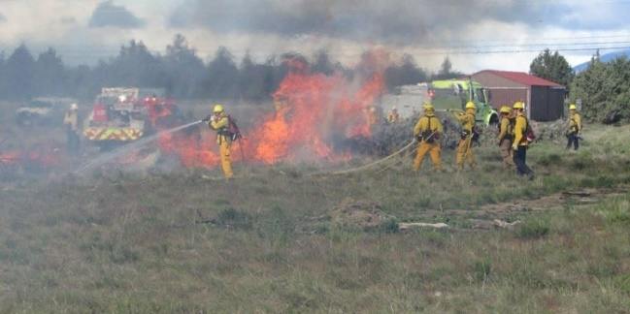

**General Fund Expenses – MATERIALS & SERVICES**



**General Fund Expenses – CAPITAL OUTLAY/GRANTS**





**General Fund Expenses – DEBT SERVICES** 

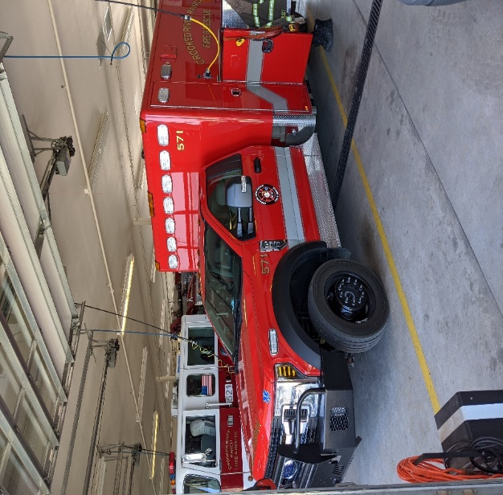

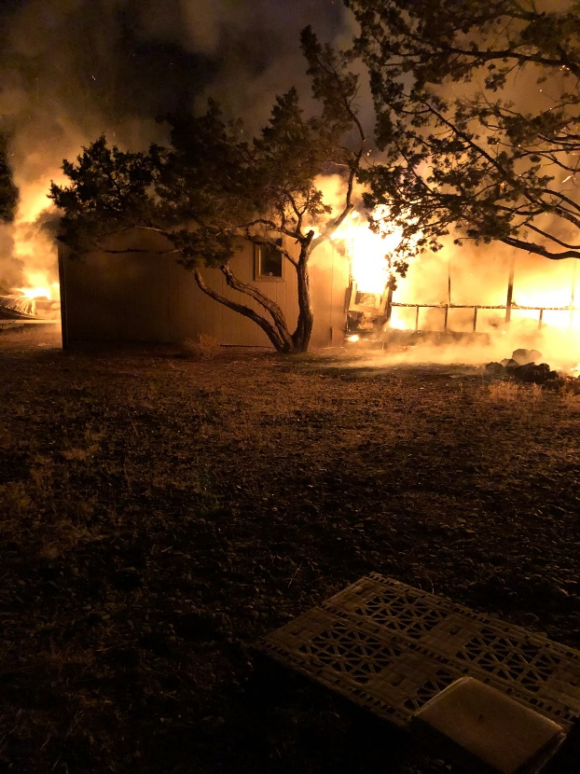

**Capital Reserve Fund**

This includes anticipated cash on hand from the carryover of 2020/2021 fiscal year, interest, and transfers in from other funds.

**Cash on hand:**

Estimated funds for beginning of fiscal year 2021/2022.

**Interest:**

Estimated from prior year actuals as compared to fund balance.

**Transferred IN, from other funds:**

Annual transfer to reserve fund, from General Fund, for future expenditures.

**Grant Funds:** At this time, we do not anticipate receiving these funds. If we are awarded any grant funds, they will be received by Resolution.

**Apparatus Capital Purchases:**

At this time, we do not plan on purchasing any apparatus.

**AFG Regional Radio Grant Expenditures**

Our portion of the regional radio grant for replacing all radios has been completed in the 2018/2019 fiscal year.

**Building Purchases:** This is the remaining amount needed to complete the training building/grounds behind the Station.

**EMS Capital Purchases**: These are funds that are set aside for the purchase of an additional Loader for the 2nd out Ambulance, as well as an additional LUCAS CPR machine. These funds will only be utilized if we are not awarded the FEMA Assistance to Firefighter grant funds that we have applied for in March 2021.

**Capital Contingency**: This is a new line item that has been added to our budget. It was recommended by our audit firm to have this available for unforeseen capital expenditures.

**Reserved for Future Expenditures:**

This line item reflects estimated reserves in the fund.

**Capital Reserve Fund**



**EMS future Capital Purchases for 2nd out ambulance:**

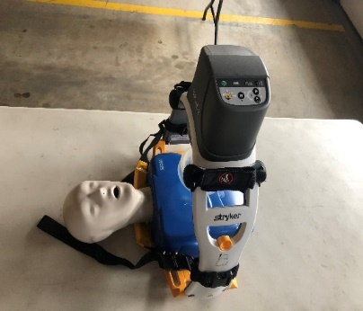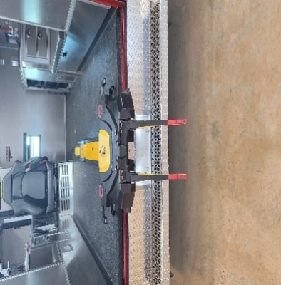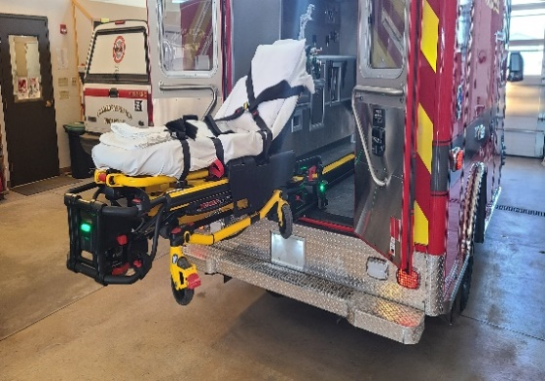

**Bond Fund (for Station)**

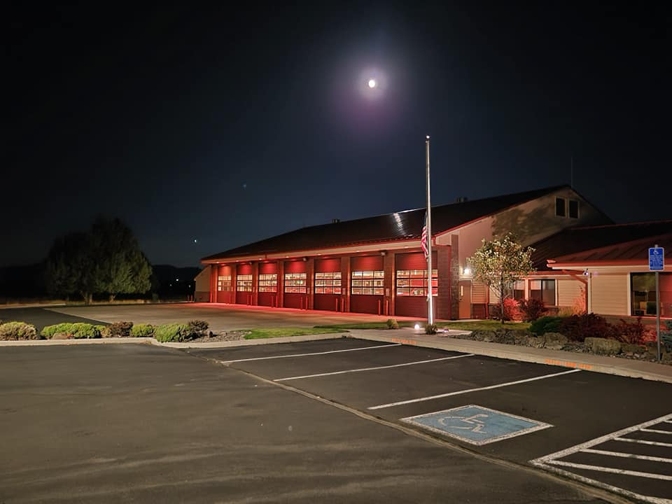

|  |  |  |  |  |  |
| --- | --- | --- | --- | --- | --- |
| **Crooked River Ranch Fire & Rescue** | | | | | |
| **General Fund Budget Variance** | | | | | |
| **For the month ended 31 March 2021** | | | | | |
| **Modified Cash Basis** | | | | | |
|  |  |  |  |  |  |
|  | **March** | **YTD Actual** | **Budget** | **Var USD** | **Var %** |
|  | **Actual** |  |  |  |  |
| **Revenue** |  |  |  |  |  |
| Ambulance Billing | $19,841.68 | $156,526.22 | $165,000.00 | -$8,473.78 | -5.1356% |
| Beginning Fund Balance: General/LO Levy Fund | $0.00 | $433,869.64 | $441,703.00 | -$7,833.36 | -1.7734% |
| Conflagration Revenue | $13,854.47 | $42,791.46 | $42,792.00 | -$0.54 | -0.0013% |
| Contractual Income | $0.00 | $800.00 | $400.00 | $400.00 | 100.0% |
| Deschutes County: General Fund | $1,765.30 | $56,569.05 | $52,612.00 | $3,957.05 | 7.5212% |
| Deschutes County: Local Option Levy Fund | $854.89 | $27,415.77 | $25,477.00 | $1,938.77 | 7.6099% |
| Emergency Address Signs | $0.00 | $325.00 | $500.00 | -$175.00 | -35.0% |
| Fire Med | $1,080.00 | $9,630.00 | $13,680.00 | -$4,050.00 | -29.6053% |
| Grant Funds | $4,470.00 | $60,248.35 | $143,977.00 | -$83,728.65 | -58.1542% |
| Interest | $648.32 | $5,077.50 | $7,500.00 | -$2,422.50 | -32.3% |
| Jefferson County: General Fund | $4,122.96 | $592,258.59 | $577,381.00 | $14,877.59 | 2.5767% |
| Jefferson County: Local Option Levy | $1,996.55 | $286,800.26 | $279,596.00 | $7,204.26 | 2.5767% |
| Miscellaneous Income | $2,369.50 | $8,185.55 | $5,000.00 | $3,185.55 | 63.711% |
| Prior Year Taxes | $2,320.28 | $25,349.84 | $20,000.00 | $5,349.84 | 26.7492% |
| Sale of Assets/Apparatus | $0.00 | $13,002.00 | $7,500.00 | $5,502.00 | 73.36% |
| Training Income | $0.00 | $0.00 | $500.00 | -$500.00 | -100.0% |
| **Total Revenue** | **$53,323.95** | **$1,718,849.23** | **$1,783,618.00** | **-$64,768.77** | **-3.6%** |
|  |  |  |  |  |  |
| **Gross Profit** | **$53,323.95** | **$1,718,849.23** | **$1,783,618.00** | **-$64,768.77** | **-3.6313%** |
|  |  |  |  |  |  |
| **Operating Expenses** |  |  |  |  |  |
| Debt Services & Contingency: Contingency | $0.00 | $0.00 | $35,696.00 | -$35,696.00 | -100.0% |
|  |  |  |  |  |  |
| **Capital Outlay & Grant Awards** |  |  |  |  |  |
| Capital Outlay & Grant Awards:  EMS Purchase | $0.00 | $10,502.00 | $10,502.00 | $0.00 | 0.0% |
| **Total Capital Outlay & Grant Awards** | **$0.00** | **$10,502.00** | **$10,502.00** | **$0.00** | **0.0%** |
|  |  |  |  |  |  |
| **Debt Service** |  |  |  |  |  |
| Apparatus Payment | $0.00 | $27,045.17 | $27,046.00 | -$0.83 | -0.0031% |
| **Total Debt Service** | **$0.00** | **$27,045.17** | **$27,046.00** | **-$0.83** | **0.0%** |
|  |  |  |  |  |  |
| **Materials & Services** |  |  |  |  |  |
| Administration | $2,350.11 | $17,476.40 | $14,608.00 | $2,868.40 | 19.6358% |
| Building & Maintenance | $768.74 | $31,224.23 | $35,000.00 | -$3,775.77 | -10.7879% |
| Department Services | $136.00 | $1,372.48 | $3,000.00 | -$1,627.52 | -54.2507% |
| Dispatch Services | $4,076.90 | $66,240.05 | $69,619.00 | -$3,378.95 | -4.8535% |
| EMS Operations | $8,300.78 | $29,551.54 | $38,266.00 | -$8,714.46 | -22.7734% |
| Fire Suppression | $341.26 | $16,169.87 | $28,080.00 | -$11,910.13 | -42.415% |
| Fuel | $857.09 | $6,692.47 | $12,000.00 | -$5,307.53 | -44.2294% |
| Insurance | $0.00 | $30,490.00 | $30,000.00 | $490.00 | 1.6333% |
| Prevention | $15.97 | $1,058.60 | $1,000.00 | $58.60 | 5.86% |
| Professional Services | $564.24 | $41,749.49 | $44,302.00 | -$2,552.51 | -5.7616% |
| Radios/Communications | $0.00 | $0.00 | $3,000.00 | -$3,000.00 | -100.0% |
| Rope Rescue Operations | $0.00 | $0.00 | $1,500.00 | -$1,500.00 | -100.0% |
| SAFER Grant Expenditures | $0.00 | $1,352.00 | $9,422.00 | -$8,070.00 | -85.6506% |
| Training | $386.60 | $9,850.49 | $15,227.00 | -$5,376.51 | -35.3091% |
| Travel | $0.00 | $144.90 | $10,488.00 | -$10,343.10 | -98.6184% |
| Tuition Reimbursement | $10,242.78 | $20,320.28 | $31,500.00 | -$11,179.72 | -35.4912% |
| Uniforms | $675.78 | $4,377.42 | $5,713.00 | -$1,335.58 | -23.3779% |
| Utilities | $2,459.77 | $16,244.34 | $22,500.00 | -$6,255.66 | -27.8029% |
| Vehicle & Equipment Maintenance | $1,736.56 | $21,509.65 | $50,077.00 | -$28,567.35 | -57.0468% |
| Volunteer Incentives | $1,980.00 | $15,460.00 | $20,800.00 | -$5,340.00 | -25.6731% |
| Wellness Program | $0.00 | $909.00 | $10,000.00 | -$9,091.00 | -90.91% |
| **Total Materials & Services** | **$34,892.58** | **$332,193.21** | **$456,102.00** | **$123,908.79** | **-27.2%** |
|  |  |  |  |  |  |
| **Personnel Services** |  |  |  |  |  |
| Administrative Assistant | $4,156.55 | $27,559.51 | $37,554.00 | -$9,994.49 | -26.6136% |
| Administrative Assistant O/T | $38.41 | $516.40 | $1,280.00 | -$763.60 | -59.6563% |
| Assistant Fire Chief | $9,651.25 | $53,708.12 | $77,174.00 | -$23,465.88 | -30.4065% |
| Employee Benefits | $12,706.18 | $116,335.62 | $183,359.00 | -$67,023.38 | -36.5531% |
| Fire Chief | $11,896.50 | $62,109.01 | $84,975.00 | -$22,865.99 | -26.9091% |
| Part-Time Employees | $0.00 | $17,941.25 | $23,520.00 | -$5,578.75 | -23.7192% |
| Payroll Taxes | $3,187.65 | $28,881.03 | $42,783.00 | -$13,901.97 | -32.4941% |
| PERS | $8,448.72 | $87,377.40 | $122,725.00 | -$35,347.60 | -28.8023% |
| Shift Personnel | $6,802.67 | $135,431.53 | $181,300.00 | -$45,868.47 | -25.2998% |
| Shift Personnel Overtime | $392.89 | $21,288.54 | $44,571.00 | -$23,282.46 | -52.2368% |
| Student Volunteer Stipends | $810.00 | $4,725.00 | $7,290.00 | -$2,565.00 | -35.1852% |
| Volunteer Conflagration Reimbursement | $0.00 | $6,181.38 | $6,525.00 | -$343.62 | -5.2662% |
| Volunteer Shift Stipends | $2,000.00 | $22,670.00 | $50,000.00 | -$27,330.00 | -54.66% |
| Workers Compensation & Group Acc Ins. | $0.00 | $14,324.64 | $16,000.00 | -$1,675.36 | -10.471% |
| **Total Personnel Services** | **$60,090.82** | **$599,049.43** | **$879,056.00** | **$280,006.57** | **-31.9%** |
|  |  |  |  |  |  |
| **Total Operating Expenses** | **$94,983.40** | **$968,789.81** | **$1,408,402.00** | **$439,612.19** | **-31.2135%** |
|  |  |  |  |  |  |
| **Operating Income / (Loss)** | **41,659.45** | **$750,059.42** | **$375,216.00** | **$374,843.42** | **99.9007%** |
|  |  |  |  |  |  |
| **Other Income and Expense** |  |  |  |  |  |
| General Fund, Transfer Out | $0.00 | $0.00 | -$135,217.00 | $135,217.00 | 100.0% |
| **Total Other Income and Expense** | **$0.00** | **$0.00** | **-$135,217.00** | **$135,217.00** | **100.0%** |
|  |  |  |  |  |  |
| **Net Income / (Loss) before Tax** | **$41,659.45** | **$750,059.42** | **$239,999.00** | **$510,060.42** | **212.5261%** |
|  |  |  |  |  |  |
| **Net Income** | **$41,659.45** | **$750,059.42** | **$239,999.00** | **$510,060.42** | **212.5261%** |
|  |  |  |  |  |  |
| **Total Comprehensive Income** | **$41,659.45** | **$750,059.42** | **$239,999.00** | **$510,060.42** | **212.5261%** |

***CORE VALUES***

*These core values have been delineated as an integral part of our District’s commitment both to an exemplary level of service and moral standard of conduct above and beyond reproach.*

***SERVICE*** *– Dedication to our Community*

***PROFESSIONALISM*** *– Honoring the Firefighter Oath*

***INTEGRIT****Y – Upholding moral and ethical conduct at all times*

***RESPECT*** *– Embracing diversity and recognizing individual worth*

***INNOVATION*** *– Taking creative risks to adapt and improve*

***TRUST*** *– Reliance on the integrity, strength, and ability of our members*

***BRAVERY*** *– Courage is the foundation of our character*

***CARING*** *– Be safe, do no harm, and be nice*

***FISCAL RESPONSIBILITY*** *– Protect the public trust by being fiscally accountable to our constituents*

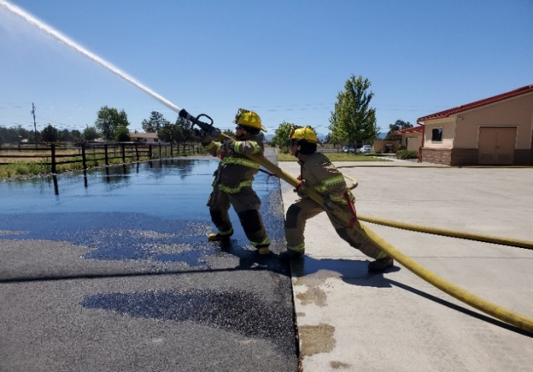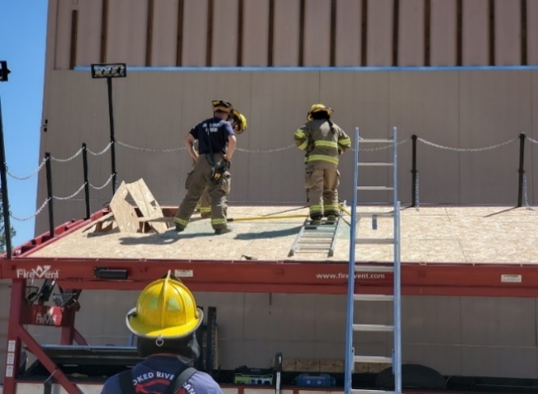

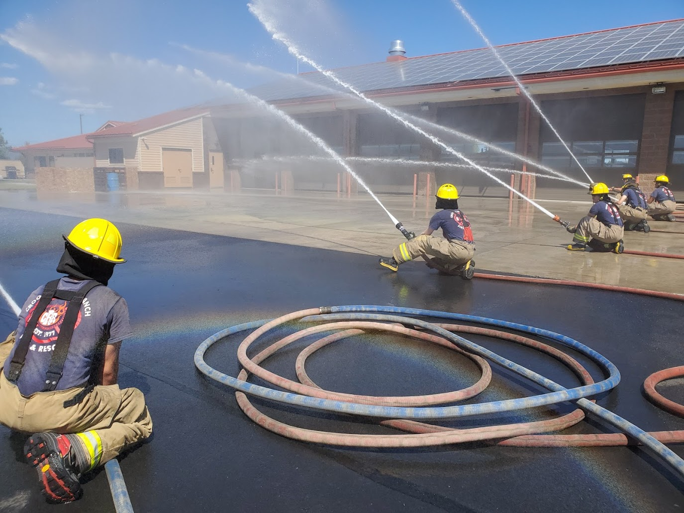

***We would like to thank our Board of Director and Budget Committee members for their time and consideration of this proposed budget.***

